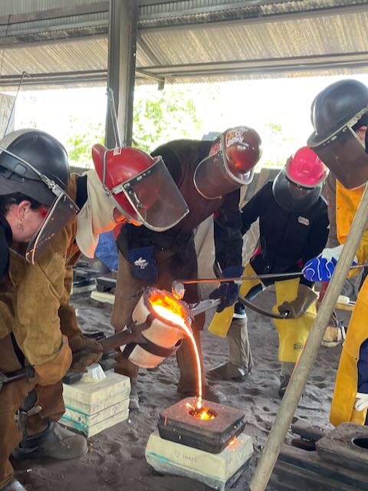

Title: Exploring Metal Casting and Collaborative Experimental Preservation

Faculty: Prof. Jorge Otero-Pailos, Prof. Kate Allen

Staff: Mika Tal, Manager, GSAPP Preservation Technology Lab

Collaborators: David Matson, Sloss Furnaces & Metal Arts, and Birmingham Sculpture, both in Birmingham Alabama.

Dates: June 2-13 (Travel to Alabama June 9-13)

Description:

Explore metal casting and collaborative craftsmanship through the lens of experimental preservation in this two-week summer workshop. This immersive program blends hands-on experiences with theoretical knowledge and creativity, offering participants a unique approach to the design, technology and craft involved in architectural heritage conservation. The workshop will include visits to buildings with significant metalwork and metal manufacturing facilities in both New York and Birmingham.

Week 1: Crafting Building Fragments (June 10-14)

In the first week, participants will immerse themselves in the art of metal casting and preservation techniques at the GSAPP Preservation Technology Lab. Guided by experienced artisans and preservation experts, students will learn to create wooden patterns, molding techniques in rubber and wax to replicate metal building fragments. Through meticulous craftsmanship, each participant will contribute to the creation of these fragments, forming a collaborative process akin to constructing a "metal quilt."

Week 2: Exploring Metal Casting and Preservation Sites (June 17-21)

The second week takes participants on a journey to historic sites and industry partners in Alabama, offering firsthand experience in metal casting and preservation practices. We'll spend 2 days at the iconic Sloss Furnaces National Historic Landmark in Birmingham, where participants will have the opportunity to pour molten iron into the molds prepared at Columbia. Participants will gain insight into ferrous metal casting techniques.

Next, a day at the Birmingham Sculpture Metal Arts Foundry will provide exposure to the ceramic shell process and lost wax method of casting, exploring nonferrous metal casting methods and expanding participants' understanding of preservation practices.

To conclude the week, participants will learn the art of applying hot and cold patinas to bronze, adding depth and character to their creations. Here, the collaborative process comes full circle as participants witness the transformation of individual fragments into a cohesive architectural grille.

Culminating Project: The Metal Quilt

Inspired by the concept of building fragments, participants will collectively fabricate and assemble the architectural grille using the fragments created throughout the workshop. This collaborative endeavor symbolizes the intersection of individual creativity and collective effort in preserving architectural heritage. Upon completion, the grille will be patinated and sent back to Columbia, where it will be hung on display as a tangible representation of the workshop's collaborative spirit.

This enriching and transformative experience is meant to introduce students to the art, science and technology of metal craftsmanship, heritage conservation, and collaborative experimental preservation practices. Together, let's weave a tapestry of architectural history through the art of metal casting.