The City of God and the Worldly City:
A Social and Architectural History of Jerusalem
ARCHA6844_001_2019_1 - SOC + ARCH HIST JERUSALEM

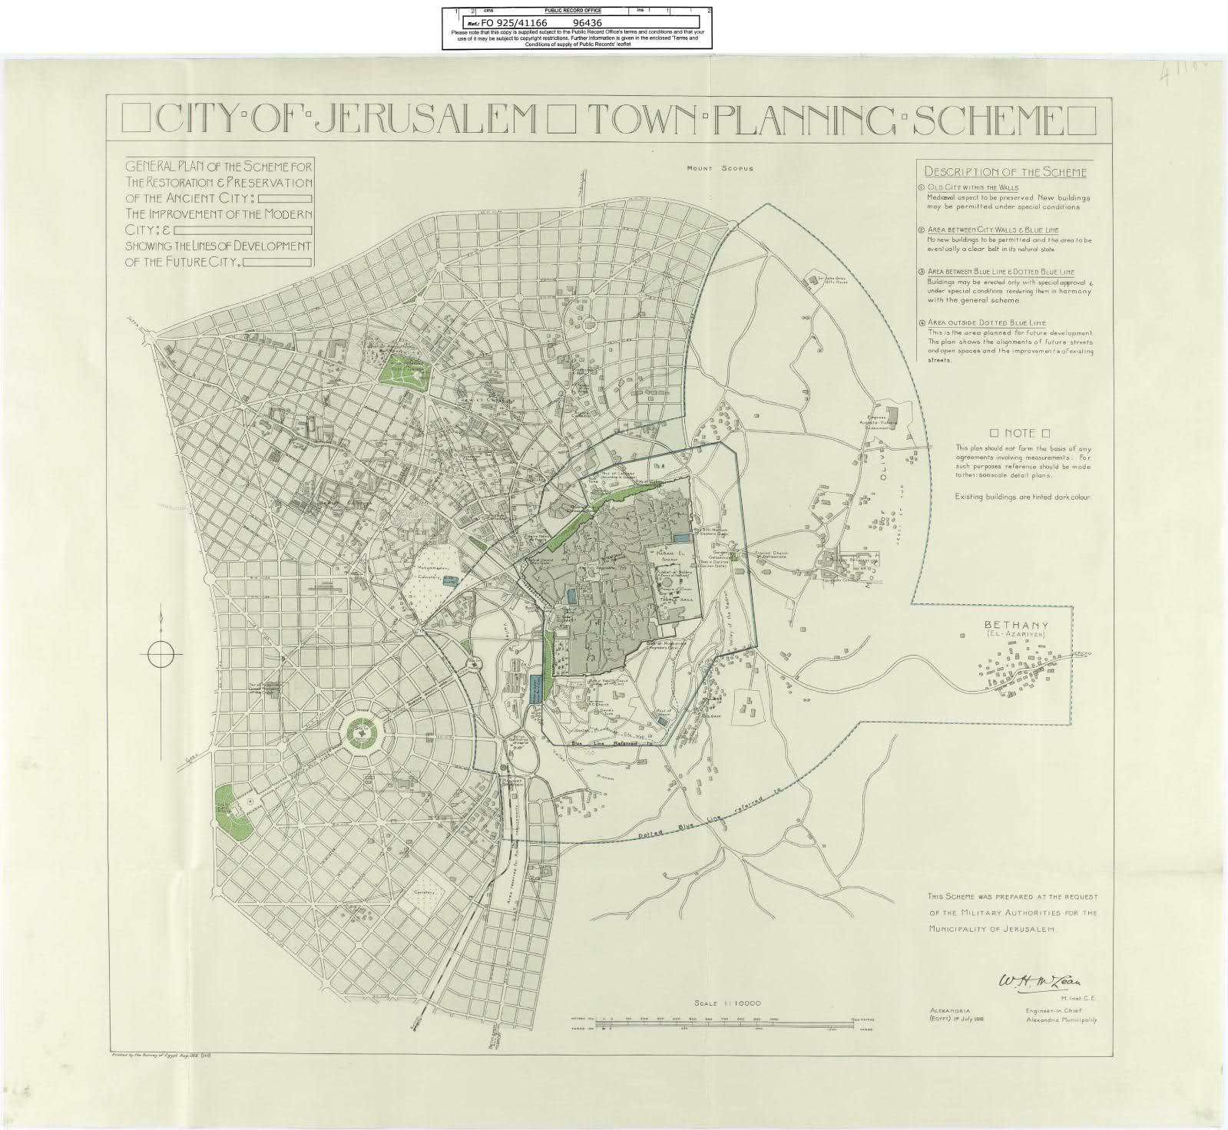

Salim Tamari and Suad Amiry

Salim Tamari
salim.tamari@gmail.com
st2698@columbia.edu

Suad Amiry
Suad.amiry@icloud.com

Wednesdays 1-3pm Avery Hall
Course Description
In Medieval sacred literature Jerusalem has been described as the Center of the World, at the crossroads of Asia, Africa and Europe. Its various names are all related to its sacred character: Elia, Yerushalaim, Al Quds, Beit al Maqdis, and Yabus. For thousands of years it has inspired and incited successive dynasties, nations and individuals with its sacred landscape, and triggered countless number of wars and conquests. For most of its recent history the number of pilgrims far exceeded its resident population. It is the only city which has a malaise named after it--the Jerusalem Syndrome refers to a psychotic obsession, triggered by visiting or making a pilgrimage to the city.
This course provides a social and architectural history of the city with a focus on issues of representation, urban form, planning, spatial contestation, and debates about the status of the city and its future. This course will also examine the sacred, imagined and worldly Jerusalem through its social history, religious rituals, the politics of archeology, planning and urban transformation, demographic debates, ethnicity, and war. It will analyze the commodification and packaging of holy city for pilgrimage and tourism. The course will address the current predicament of the city and its future within the context of the Arab Israeli conflict. More specifically the course will address the following issues:
      - The meaning of sacredness. How did the notion of sacredness emerge in Jerusalem? What made Jerusalem the center of pagan worship (Jebusite, Canaanite) and the magnet for the Jewish, Christian and Islamic religions. The persistence of pagan ritual in contemporary religious ritual of shrine and maqam celebrations.
      - Architectural history of the Old City: The Roman-Byzantine city; layers of the walled city and its water networks; sacred sites and monuments; Roman, Israelite, Herodian, Byzantine, Mameluke, Crusader, Fatimid, and Ottoman, landmarks, and Ottoman era spatial organization; Ottoman public monuments, residential quarters, markets, holy sites, schools, zawiyas, and public baths; 19 century European public buildings—hospitals, schools, churches, libraries, and consular buildings. The growth of planned neighbourhoods outside the city wall (1870-1940s).

      - The Cartography and Ethnography of Early Modern Jerusalem--The imagined city in pilgrimage, crusader campaigns, counter-crusades, and fictional travelogues (Innocents Abroad, the geographic adventures of Katib Celebi) examining five centuries of mapping Jerusalem, beginning with Peri Reisi strategic mapping of the Syrian Coast, and Celebi’s 17th century ethnographic mapping; the Palestine Exploration Fund and its Jerusalem excavations. Visual Jerusalem: A survey of early photography, film and travel paintings of the holy city—beginning with the cartographic aerial photography of the German Air Force in 1917-1918; The Politics of Archeology. The contestation of the city seen in archeological investigations—Biblical, Islamic and Secular.
      - The Sacred City Commodified: The Selling of Jerusalem. Tourist guides and the commodification of the sacred city. The packaging of the city for tourists and pilgrims. A discussion of Annabel Wharton’s Selling Jerusalem: Relics, replicas, theme parks. (2006) Travel and Pilgrimage literature from Jewish, Islamic and Christian sources.
      - Planning and Modernity. Ottoman and Colonial planning of Jerusalem in the nineteenth and early twentieth centuries. Ottoman urban planning; City zoning laws of 1876; McLean 1918 plan; Ashby 1919; Geddes 1929; Henry Kendell, 1944, The Work of the Pro-Jerusalem Society, 1918-1922; The Colonial City and Corpus Separatum (1947).

      - Planning the Future of Jerusalem; the Colonial City Scenarios for a binational city; Waqf, real estate, and rehabilitation schemes in the old city. One Jerusalem or two Jerusalems. Return to Corpus Separatum. Schemes for an integrated bi-national city in the peace negotiations (1996-2004); Proposal for Jerusalem as an international city (1947): schemes for a shared city. The Divided City: Navigating the City through barbed wires (Jordanian and Israeli Jerusalem 1948-1967). Post 1967 spatial reconfiguration of the city under Israeli rule. The Separation Wall--The Arab city and the Jewish City; Jerusalem and its West Bank hinterland; The Demographic-Territorial Dilemma: Settlements, Zoning Laws, Residency regulations, and demographic debates. Israeli greening schemes and transport networks.

      - Archival Sources for spatial analysis: Bavarian State Archives aerial photography (1918); Municipal Archives (1876-1914); Mapping Collection of Jerusalem at the Israeli National Library; Court Records; Jerusalem Municipal Archives; Riwaq’s National Registry of city buildings and survey; Ethnographic and Mapping Survey of the Palestine Exploration Fund; Endangered Collection of Jerusalem Manuscripts at the British Library; Columbia University Jerusalem digital archive; the Open Jerusalem Archive (Venice, Paris).

Course Prerequisites and Requirements
Course will be a graduate seminar open to senior students in architecture, and the social sciences. Students taking the course will be expected to participate in the readings and write one research paper on one of the themes discussed in class. Grades will be distributed as follows: Class Participation and Presentation 25%, Mid-term: 25%, Research Paper 50%,
Primary Texts
*Zeynep Celik EMPIRE, ARCHITECTURE, AND THE CITY, University of Wasington Press, Seatle, 2008 (PDF available)
Simon Sebag Montefiore, Jerusalem: The Biography. Weidenfeld and Nicholson, 2011
*Annabel Jane Wharton, Selling Jerusalem: Relics, Replicas, Theme Parks University of Chicago Press, 2006 (to be purchased)
Angelos Dalachanis and Vincent Lemire, Ordinary Jerusalem 1840–1940, Opening New Archives, Revisiting a Global City (Free Download)
Benvenisti, Meron, City of Stone: The Hidden History of Jerusalem
Wasif Jawhariyyeh, The Storyteller of Jerusalem, Interlink, 2013 (PDF)
Michael Dumper, Jerusalem Unbound: Geography, History and the Future of the Holy City, Columbia University Press, 2014 (PDF)
Adina Hoffman, Till We Have Built Jerusalem: Architects of a New City, Farrar Straus, and Giroux, 2016
Salim Tamari, Jerusalem 1948, Institute of Jerusalem Studies, Jerusalem (PDF available)
Grabar, Oleg, The Shape of the Holy (Princeton 1996).
Suad Amiry, Golda Slept Here, Bloomsbury, London, 2014
Suad Amiry, Space, Kinship and Gender, Riwaq, 2018
Suad Amiry with Rana Anani, Throne Village Architecture: 2003

Readings and Course Meetings

Week One (January 23, 2019):
An Overview for Planning Jerusalem: The Worldly City and its Sacred Domain:

The Jerusalem Syndrome—what accounts for the sacredness of the city throughout successive regimes? Religion and Territoriality. The City of Pilgrimage. Syncretic Religiosity: Shrines, Saints and Maqamat. The City and its Hinterland. Jerusalem’s Ottoman Modernity: Planning and Architectural Styles. The Divided City: Territoriality and Contestation.

Week Two (January 30, 2019):
Territoriality and Sacredness

How did the notion of sacredness emerge in Jerusalem? What made Jerusalem the center of pagan worship (Jebusite, Can’anite) and the magnet for the Jewish, Christian and Islamic religions?
David Wasserstein, “The Heavenly City and the Earthly City” in Divided Jerusalem, Prologue (1-14), and Epilogue, The Earthly City, 345-360
Rashid Khalidi, Sacred Topology, Jerusalem Quarterly
Karen Armstrong, The Holiness of Jerusalem: Asset or Burden? Journal of Palestine Studies, Vol. 27, No. 3 (Spring, 1998), pp. 5-19

Week Three (February 6, 2019):
The Quarry of History and the Borders of Holiness
Benvenisti Meron, The Quary of History, City of Stone: The Hidden History of Jerusalem, pp. 1-50
Kamel Asali, K. L., Jerusalem in History New York 2002 Introduction
Michael Dumper, The Scattered Borders of Holiness, in 97-145, in Jerusalem Unbound: Geography, History and the Future of the Holy City, Columbia University Press, 2014
Week Four (February 13, 2019):
The Cartography and Ethnography of the City
Dov Gavish “An Account of an Unrealized Aerial Cadastral Survey in Palestine under the British Mandate” The Geographical Journal, Vol. 153, No. 1 (Mar., 1987), pp. 93-98 (PDF available)
Nada Atrash “Mapping Palestine: The Bavarian Air Force WWI Aerial Photography”, Jerusalem Quarterly, no. 56/57 (download directly from google)

Salim Tamari, “Arabs Turks and Monkeys: The Ethnography and Cartography of Syria”, in The Great War and the Remaking of Palestine, (pdf available)

Ruth Kark, Planning and Cadastral Surveys (source to be added)

National Registry of Historical Buildings (Jerusalem), Riwaq

Week Five (February 20th, 2019):
The City and its Hinterland: Early Planning and Urban Form
Arieh Sharon, Planning Jerusalem: the old city and its environs Source: Ekistics, Vol. 38, No. 228, CITIES OF THE PAST (NOVEMBER 1974), pp. 368-376 (PDF Available)
Alexander Scholch, Feudal Jerusalem (From “Radical Transformation of Palestine”)
Suad Amiry: Space, Kinship and Gender (2017): Chapters 2-4 (pages 43-163)
Suad Amiry: Throne Village Architecture (2003) English Introduction 1-19

Week Six (February 27th, 2019):
Spectacularized Jerusalem: The packaging and commodification of the Holy City

Beatrice St. Laurent and Himmet Taskömür. "The Imperial Museum of Antiquities in Jerusalem, 1890-1930: An Alternative Narrative" Jerusalem Quarterly (2013) Available at:
http://works.bepress.com/beatrice_stlaurent/5/

Annabel Jane Wharton, The City as Gift Chapters 1-3 in Selling Jerusalem: Relics, Replicas, Theme Parks

Jeroen Goudeau, Mariëtte Verhoeven, Wouter Weijers, The Imagined and Real Jerusalem in Art and Architecture (Selected chapters), 2014, Brill (Open Access Book)

Week Seven (March 6th, 2019):
Excavating Jerusalem: The Politics of Archeology

“Excavating Jerusalem” in Archaeological Practice and Territorial Self-Fashioning in Israeli Society by Nadia Abu El-Haj, Facts on the Ground pp. 130-163 (PDF Available)
62
Katerina Golor, King Herod in Jerusalem: The Politics of Cultural Heritage—The Jerusalem Quarterly (no. 65)
Download from http://www.palestine-studies.org/jq/fulltext/77897

Week Eight (March 13th):
Ottoman Modernity—the City Transformed
Rochelle Davis, “The Expansion of the Western Suburbs” (in Jerusalem 1948—available for free download)
Michelle Campos, Sacred Liberty (ch. 2), in Ottoman Brothers, pp. 20-59 (Book Available in PDF for free download)
Abigail Jacobson, Between Ottomanism and Zionism, in From Empire to Empire, pp. 82-117
Suad Amiry, Golda Slept Here, Bloomsbury, London, 2014 (PDF copy available)
Salim Tamari, “City of Riffraff: Crowds, Public Space, and New Urban Sensibilities in War-Time Jerusalem, 1917-1921”, in Comparing Cities: The Middle East and South Asia, by Kamran Asdar Ali and Martina Rieker, ed. Oxford: Oxford University Press. 2010. Download from link below.

https://www.palestine-studies.org/institute/fellows/city-riffraff-crowds-public-space-and-new-urban-sensibilities-war-time-jerusalem-0

Salim Tamari. “The Sweet Smell of Holy Sewage: Urban Planning and the Remaking of the Public Sphere in Ottoman Palestine” (PDF download)

Week Nine (March 27):

Planning Schemes I: Early British Mandate
Raquel Rapaport “The City of the Great Singer: C. R. Ashbee's Jerusalem”. Architectural History, Vol. 50 (2007), pp. 171-210 (pdf available)
INBAL BEN-ASHER GITLER, "Marrying Modern Progress with Treasured Antiquity": Jerusalem City Plans during the British Mandate, 1917-1948 (PDF Available)
Nicholas E. Roberts “Dividing Jerusalem: British Urban Planning in the Holy City”, Journal of Palestine Studies , Vol. 42, No. 4 (Summer 2013), pp. 7-26 (PDF available)
Rana Barakat. Urban Planning, Colonialism, and the Pro-Jerusalem Society, The Jerusalem Quarterly (65), 2016

Week Ten (April 3, 2019):
Planning Schemes II: Zionism and Colonialism
Noah Esther Hysler Rubin, “Geography, colonialism and town planning: Patrick Geddes' plan for mandatory Jerusalem” Cultural Geographies, Vol. 18, No. 2 (April 2011), pp. 231-248 (PDF Available)
Shaul E. Cohen, “Greenbelts in London and Jerusalem”, Geographical Review, Vol. 84, No. 1 (Jan., 1994), pp. 74-89 (pdf available)
Mark LeVine, “Globalization, Architecture, and Town Planning in a Colonial City: The Case of Jaffa and Tel Aviv”, Journal of World History, Volume 18, Number 2, June 2007, pp. 171-198
Week Eleven (April 10th, 2019):
Architecture, Public Endowments and Family Waqf
Ruba Kanaan, “Waqf, Architecture, and Political Self-Fashioning: The Construction of the Great Mosque of Jaffa by Muhammad Aga Abu Nabbut Muqarnas”, Vol. 18 (2001), pp. 120-140
Salim Tamari, “Waqf Endowments in the Old City of Jerusalem”, in Ordinary Jerusalem (PDF available)
Konstantinos Papastathis, Ruth Kark , “The Politics of church land administration: the Orthodox Patriarchate of Jerusalem in late Ottoman and Mandatory Palestine, 1875–1948” (PDF available)

Week Twelve (April 17th, 2019):

The City Divided: War and Conquest

David Wasserstein, Two Jerusalem’s 179-205 in Wasserstein Divided Jerusalem, Yale University Press,
Ibrahim Dakkak, “Jerusalem's via Dolorosa”, Journal of Palestine Studies, Vol. 11, No. 1, (PDF available)
Scott A. Bollens, “ON NARROW GROUND: PLANNING IN ETHNICALLY POLARIZED CITIES” Journal of Architectural and Planning Research, Vol. 13, No. 2 (Summer, 1996), pp. 120-139 (pdf available)
Abigail Jacobson, A Multi-Ethnic City in Times of Acute Crisis, in Between Ottomanism and Zionism, in From Empire to Empire, pp. 22-52
Week Thirteen (April 24th, 2019):
The Politics of Contemporary Jerusalem
Michael Hudson, “The Transformation of the City: 1917-2000” in Assali, Jerusalem in History 249-265
Michael Dumper, “The Limits of Sovereignty” (146-185)
Michael Dumper, “Jerusalem in the Twenty-First Century: Prospects for Peace” (186-237) in Dumper, Jerusalem Unbound, Columbia University Press, 2014
Week Fourteen (May 1, 2019)
Presentation of Papers
.

Selected Bibliography

Kendall, Henry. 1948. Jerusalem, the city plan preservation and development during the British Mandate, 1918-1948. London: H.M. Stationery Off.

Wharton, A. J. (2006). Selling Jerusalem: Relics, replicas, theme parks. Chicago: University of Chicago Press.

Kark, Ruth. 1991. Jerusalem neighborhoods: planning and by-laws, 1855-1930. Jerusalem: Mount Scopus Publications by the Magnes Press, Hebrew University.

Kark, Ruth, and Michal Oren-Nordheim. 2001. Jerusalem and its environs: quarters, neighborhoods, villages, 1800-1948. Jerusalem: Hebrew University Magnes Press.

Rana Barakat. Urban Planning, Colonialism, and the Pro-Jerusalem Society, The Jerusalem Quarterly (65), 2016

Ḳroyanḳer, Daṿid. 1985. Jerusalem: planning and development, 1982-1985 : new trends. [Jerusalem, Israel]: [Jerusalem Foundation].

Chiodelli, Francesco. 2017. Shaping Jerusalem: spatial planning, politics and the conflict. London, Routledge
Felner, Etan. 1997. A policy of discrimination: land expropriation, planning and building in East Jerusalem. Jerusalem: B'tselem.

Misselwitz, Philipp, Tim Rieniets, Zvi Efrat, Rassem Khamaisi, and Rami Nasrallah. 2006. City of collision: Jerusalem and the principles of conflict urbanism. Basel: Birkhäuser.

El-Eini, Roza. 2006. Mandated landscape: British imperial rule in Palestine, 1929-1948. London: Routledge.

Dumper, Michael. 2014. Jerusalem unbound: geography, history, and the future of the holy city. Columbia University Press

Dumper, Michael. 2003. The politics of sacred space: the old city of Jerusalem in the Middle East conflict. Boulder, Colo: Lynne Rienner Publishers.

Monterescu, Daniel, and Dan Rabinowitz. 2017. Mixed towns, trapped communities: historical narratives, spatial dynamics, gender relations and cultural encounters in ethnically mixed towns in Israel/Palestine. Routledge, London

Tamari, Salim. "The Sweet Aroma of Holy Sewage: Urban Planning and the New Public Sphere in Palestine." (2017). In The Great War and the remaking of Palestine. Oakland, California: University of California Press.

Khasawneh, Diala, Mia Gröndahl, and Firas Rahhal. 2007. Memoirs engraved in stone: Palestinian urban mansions. Ramallah: Riwaq - Centre for Architectural Conservation [u.a.].

Riwaq, National Registry of Historic Buildings, Vol. I, Markaz alMiʻmåar ashSaʻbåi. (2006). Siǧill Riwāq li-l-mabānī at-tārīḫīya fī Filasṭīn: Muǧallad 1. Rāmallāh.

Pro-Jerusalem Society., Ashbee, C. R., Creswall, K. A. C., Pro-Jerusalem Society., & Pro-Jerusalem Society. (1921). Jerusalem: Records of the Pro-Jerusalem Council, 1918-1922. London: J. Murray, published for the Council.

Crawford, A. (2005). C.R. Ashbee: Architect, designer & romantic socialist. New Haven [Conn.: Yale University Press.
Palestine Exploration Fund., Besant, W., Conder, C. R., Dalton, J. N., Petrie, W. M. F., Tristram, H. B., Wilson, C. W., ... Wright, W. (1892). [The city and the land: A course of seven lectures on the work of the society, delivered in May and June, 1892]. London: Published for the Committee of the Palestine Exploration Fund by A.P. Watt.

Jacobson Abigail, From Empire to Empire, Jerusalem between Ottoman and British Rule, New-York, 2011
Khalidi Rashid, Palestinian Identity: The Construction of a Modern National Consciousness, New York, 1997
Campos Michelle, Ottomans Brothers. Muslims, Christians and Jews in Early-Twentieth Palestine, Stanford, 2010
Lemire Vincent, Jérusalem 1900. La ville sainte à l’âge des possibles, Paris, 2012 Halper Jeff, “On the Way: The Transition of Jerusalem from a Ritual City to a Colonial City”
Abu El Haj, Facts on the Ground (Chicago 2002)
Grabar, Oleg, The Dome of the Rock (Harvard Belknap 2006).

